Overview:
‘The Budgeting App’ is a simple personal budgeting app that has been designed to minimize steps for people to track their income, expanses and transactions between accounts (Gooch, 2025). Some nice to have features are locked behind a paywall, but the core budget tracking functionality is available in the free version, though with limitations with the number of books, accounts, and savings trackers (The Budgeting App, [s.a.] b).
Books are top level containers where you can log your budgets and track your savings and debts. Your book shows you’re your actual balance across accounts including having an advanced search to find transactions.
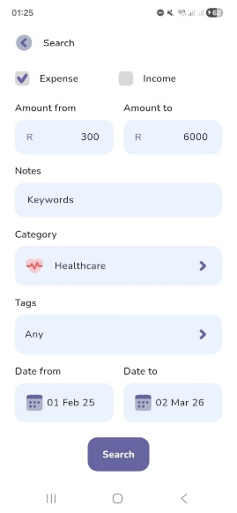
Figure 1 Books Advanced Search
To log transactions stress free the app focus on capturing incomes and expanses with the amount and a category. Other optional meta data can be added such as notes, tags, reminders and transaction recurrences.
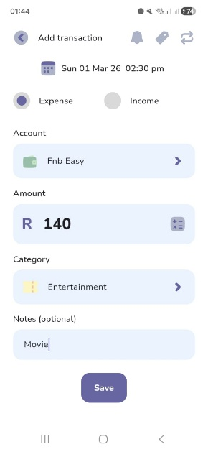
Figure 2 Log Transaction
A focus is placed on your how often you get paid (The Budgeting App, [s.a.] a). You can view your book with the actual balances your accounts and a grand total for your book. You can choose for your home page to show only income and expenses that have happened in the cashflow view. Or with the forecast view that also shows expected finances related to upcoming bills & incomes. If you overspend on your budget, you can carry over the expenses in your next pay cycle period (TBA_Jeremy, 2024).
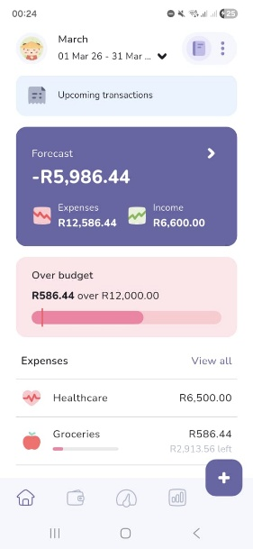
Figure 3 Budget Forecast
The onboarding process guides the user to set a budget per category of expected expenses and set goals on reaching target incomes. Challenges continue by letting the user discover how to create trackers for saving and debt management. A user can at any time transfer some of their budget towards their trackers and allocate money towards a saving goal or a loan that they are paying off.
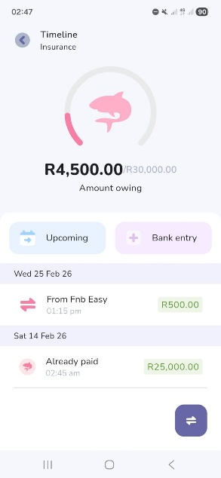
Figure 4 Loan Tracker

Users collect achievements where the app encourages users to stay consistent with streaks, stay disciplined and consistent. Challenges are failable meaning there are game like stakes when not completing a challenge, this father encourages users to continue to use the app and budget their finances.
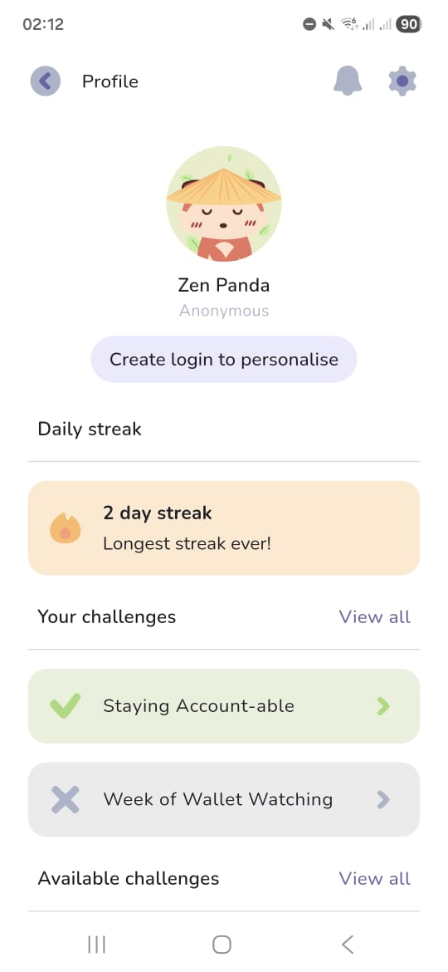
Figure 5 Profile Challenges
The app has various free and paid analysis tools to help you analyse your money. Most of the analysis tools compare income vs expenses, predicted budget vs actual amounts, top expenses and income categories, averages per pay cycle period, days no amount was spent and various other graphs, charts, calendars and tables.
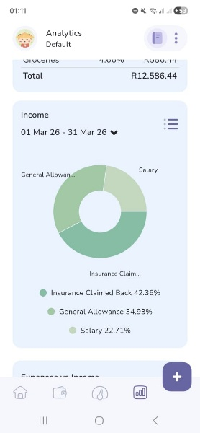
Figure 6 Income Pie Chart

Strengths:
- Many users on the Play Store praise it for having a simple and Intuitive user interface (The Budgeting App, 2022).
- Supports cloud sync with access on multiple devices (Natile, 2024)
- Onboarding and clickable pop-ups helps the user discover app features
- Can customize views to show less details like income or the remaining budget
- Export data to CSV
- Many analysis
Weaknesses:
- Cannot import history via a csv
- Doesn’t automatically sync transactions with your bank
Innovative Features:
- Built in calculator on logging page
- Biometric App lock
- Gamification for on-boarding and failable challenges razing stakes for users to be more engaged with the app and budgeting
- Can export data to CSV
- Set reminders to review budget

531 words, trimmed down to the max!
References:
The Budgeting App, 2022. Budgeting App - Spend Tracker. Version 5.9.8. [App] Available at: <https://play.google.com/store/apps/details?id=com.thebudgetingapp.thebudgetingapp&pcampaignid=web_share> [Accessed 1 March 2026].
The Budgeting App, [s.a.]. The quick way to budget. [Online] Available at: <https://thebudgeting.app/> [Accessed 1 March 2026].
The Budgeting App, [s.a.]. Plans. [Online] Available at: <https://thebudgeting.app/plans/> [Accessed 1 March 2026].
Natile, 2024. The Budgeting App. [Online] Available at: <https://betalist.com/startups/the-budgeting-app> [Accessed 1 March 2026].
Gooch. C, 2025. Young couple design their own budgeting app, save enough to buy a house. [Online] Available at: <https://www.thepress.co.nz/business/360564404/can-budgeting-really-be-fun-two-app-developers-think-so> [Accessed 1 March 2026].
TBA_Jeremy, 2024. How to use the roll-over budget feature. [Reddit] 1 December. Available at: <https://www.reddit.com/r/thebudgetingapp/comments/1h4d831/how_to_use_the_rollover_budget_feature/?utm_source=share&utm_medium=web3x&utm_name=web3xcss&utm_term=1&utm_content=share_button> [Accessed 1 March 2026].
(TBA_Jeremy, 2024)

I AM TOO LAZY TO DO IMAGE CITATIONS… WILL HELP IN REF COMPILATION LATER ;]

